Feasibility Evidence Description (FED)

<Project Title>

<Team No>

<Team members and roles>

<Date>

Version History
Date | Author | Version | Changes made | Rationale
08/20/05 | PP | 1.0 | - Original template for use with LeanMBASE v1.0 | - Initial draft for use with LeanMBASE v1.0
08/30/06 | SK, RT | 1.6 | - Add template table  - Remove Section 3. Requirement Traceability | - Consistent format  - Move to Supporting Information Document
10/06/06 | SK | 1.61 | - Removed Section 1.6 | - Section 1.6 was duplicated with section 1.7 due to Format error
09/14/07 | SK | 1.9 | - Updated Section 2 | - Consistent with LeanMBASE1.9
08/25/08 | IC | 2.0 | - Moved Section 1.1 to 1.2  - Add Section 1.2  - Updated Section 3 and add 3.1-3.3  - Updated Section 6, 6.3 | - Consistent with IICM-Sw
08/14/09 | SK | 2.1 | - Embedded description in each Table  - Moved Section 2 Business Case Analysis to Section 5  - Moved Section 3 Architecture Feasibility into Section 4.3 Feasibility Evidence  - Added Section 4 NDI/NCS Feasibility Analysis  - Added Section 6 Conclusion and Recommendation | - To be consistent with ICM EPG template set standard V2.1  - To leanify the artifact  - To add more sections about NDI/NCS assessment evidence.

Table of Contents
Feasibility Evidence Description (FED) i
Version History ii
Table of Contents iii
Table of Tables iv
Table of Figures v
1. Introduction 1
1.1 Purpose of the FED Document 1
1.2 Status of the FED Document 1
2. Process Feasibility 2
3. Risk Assessment 3
4. NDI/NCS Feasibility Analysis 4
4.1 Assessment Approach 4
4.2 Assessment Results 4
4.3 Feasibility Evidence 6
5. Business Case Analysis 8
5.1 Market Trend and Product Line Analysis 8
5.2 Cost Analysis 8
5.3 Benefit Analysis 9
5.4 ROI Analysis 9
6. Conclusion and Recommendations 11

Table of Tables
Table 1: Rationales for Selecting Architected Agile Model 2
Table 2: Requirement Prioritization 2
Table 3: Risk Assessment 3
Table 4: NDI/NCS Products Listing 4
Table 5: Evaluation Criteria – NDI /NCS Attributes 4
Table 6: Evaluation Criteria - NDI/NCS features 5
Table 7: Evaluation Results Screen Matrix 5
Table 8: Level of Service Satisfiability Evidence 6
Table 9: Level of Service Implementation Strategy 6
Table 10: Capability Feasibility Evidence 6
Table 11: Evolutionary Feasibility Evidence 7
Table 12: Market Trend and Product Line Analysis 8
Table 13: Personnel Costs 8
Table 14: Hardware and Software Costs 9
Table 15: Benefits of xxx System 9
Table 16: ROI Analysis 9

Table of Figures
Figure 1: ROI Analysis Graph 10

Introduction

Purpose of the FED Document
<< Discuss the purpose of the FED>>

Status of the FED Document
<< Discuss the status of the FED especially key differences from the previous version, for example
- The risk of possible components mismatch has been removed
- The client postponed the hardware acquisition to next fiscal year and business case analysis is updated accordingly. >>

Process Feasibility
<< Based on process decision table provided in ICM EPG> Concept: Process Decision Selection Guidelines, Identify which process model you are following and provide rationale why that model would fit your development project. >>
Table 1: Rationales for Selecting Architected Agile Model
Criteria | Rationales
Size, Complexity
Change Rate % /Month
Criticality
NDI Support
Org/Personnel Capability
Key Stage I Activities : Incremental Definition
Key Stage II Activities: Incremental Development, Operations
Time per Build;
Time per Increment

<< For NDI-Intensive and Net-Centric Services projects, if you have to develop some glue code or custom code, please note that since CSCI577ab has a fixed schedule, so we follow the concept of schedule as independent variable (SAIV). Explain how many module you have to custom code or glue code and how your team plans to implement all the required modules to make your project feasible. For example, you may plan to implement all must-have priority requirements in first increment and should-have priority requirements in the second iteration>>

Table 2: Requirement Prioritization
Priority | Requirements | References | Increment #

Risk Assessment
<< Identify our project risk, its exposure and its mitigation plan. Please note risk is a threat or probability that something will happen and possibly create loss or injury. So, if your threat or your incident is already happened, then it is a problem, not a risk. More example of risks can be found at ICM EPG> Task: Assess and Plans to Mitigate Risks>>
Table 3: Risk Assessment
Risks | Risk Exposure |  |  | Risk Mitigations
Risks | Potential Magnitude | Probability Loss | Risk Exposure | Risk Mitigations

NDI/NCS Feasibility Analysis

Assessment Approach
<< Identify the approach in assessing NDI/ NCS component candidates. Discuss the instruments and facilities that you are using.>>

Assessment Results

NDI/NCS Candidate Components (Combinations)
<< Identify all candidate commercial off-the-shelf, government-off-the-shelf, research-off-the-shelf, open source software, libraries, and net-centric services component that you are using/ plan to use. Also identify the purpose of each component. If you have to use multiple NDI/NCS to satisfy the objectives & constraints and priorities, group them in combination set. >>
Table 4: NDI/NCS Products Listing
NDI/NCS Products | Purposes

Evaluation Criteria
<< Identify the evaluation criteria in term of NDI/NCS attributes. The full list of NDI/NCS attributes can be found at ICM EPG> Concept: NDI/NCS attribute. If the list does not cover the attribute that you are looking for, you can add / remove the attributes from the list. Assign weight of each evaluation criteria by discussing with clients and project team members. Make sure the total weight is 100. >>

Table 5: Evaluation Criteria – NDI /NCS Attributes
No. | Evaluation Criteria – NDI/NCS attributes | Weight
 | Total | 100

<< The following table allows you to show how the candidate components (combination) will satisfy the capability/ product win conditions that have been negotiated in WinWin Negotiation. By using the capability win conditions and their priority, create list of features and their weight. The features could also be split into second level features if required. The weight of each features are from the priority of each win condition derived from WinWin negotiation. Make sure the total weight is 100. >>

Table 6: Evaluation Criteria - NDI/NCS features
No. | NDI/NCS Features/ sub features | Weight
 | Total | 100

Evaluation Results Screen Matrix
<< The following table reports the results of components (combinations) evaluation based on features criteria and weight that has been defined in Table 5 and Table 6. You could have two evaluation results screen matrix; one is from Table 5 and the other one from Table 6. Assuming that you have 4 NDI/NCS evaluators (r1-r4), each person will evaluate and score on each feature. The score will be averaged and multiplied for the total score. Example can be found at ICM EPG> Task: Assess / Evaluate NDI/NCS components. >>

Table 7: Evaluation Results Screen Matrix
No | W | Component 1 |  |  |  | AVG | Total | Component 1 |  |  |  | AVG | Total | Component 1 |  |  |  | AVG | Total
No | W | R1 | R2 | R3 | R4 | AVG | Total | R1 | R2 | R3 | R4 | AVG | Total | R1 | R2 | R3 | R4 | AVG | Total
1
2
3
4
5
6
Total | 100

Feasibility Evidence
<< Provide evidence or rationale of why do you think the following LOS, capability, and evolutionary win conditions are satisfiable. Example of product and process strategies can be found in ICM EPG> Task: Provide Architecture Feasibility Evidence>>

Level of Service Feasibility
<< If the selected NDI/NCS’s performance satisfies level of service win condition, show the rationale or evidence that the LOS is achievable in Table 8>>
Table 8: Level of Service Satisfiability Evidence
Level of Service Win Condition | Rationale
LOS-x: << LOS name>> | << Provide evidence or rational to show that this Level Of Service win condition is achievable. >>

<< If the selected NDI/NCS’s performance does not satisfy level of service win condition, explain your product and process strategies of how to implement your system in order to satisfy the LOS win condition. Example of product and process strategies can be found in ICM EPG> Task: Provide Architecture Feasibility Evidence. >>

Table 9: Level of Service Implementation Strategy
Level of Service Win Condition | Product Satisfaction
LOS-x: << LOS name >> | Product Strategies: <<Identify product-related strategies that can make you achieve this requirement. >>
LOS-x: << LOS name >> | Process Strategies: <<Identify process-related strategies that can make you achieve this requirement. >>
LOS-x: << LOS name >> | Analysis: << Provide rationale to support your strategies>>
 | Product Strategies:
 | Process Strategies:
 | Analysis:

Capability Feasibility
Table 10: Capability Feasibility Evidence
Capability Requirement | Product Satisfaction
CR-1: << CR name >> | Software/Technology used: <<identify the software/technology that is/are used to develop this capability requirement>>
CR-1: << CR name >> | Feasibility Evidence: << briefly provide rationale of how this capability could be developed to satisfy the requirements. >>
CR-1: << CR name >> | Referred use case diagram: << identify related use case diagram >>
 | Software/Technology used:
 | Feasibility Evidence:
 | Referred use case diagram:
 | Software/Technology used:
 | Feasibility Evidence:
 | Referred use case diagram:

Evolutionary Feasibility
Table 11: Evolutionary Feasibility Evidence
Evolutionary Win Condition | Rationale
ER-x: << ER name>> | << Provide evidence or rational to show that this Evolutionary win condition is achievable. >>

Business Case Analysis

Market Trend and Product Line Analysis
<< Briefly analyze the market trend, product popularity, product market standpoint, predicted longevity of the company and etc. Also analyze the related products that are developed/ launched by the same company/ organization. >>

Table 12: Market Trend and Product Line Analysis
 | Component 1 | Component 2 | Component 3
Market Trend
Product Line

Cost Analysis
<< Identify all possible cost either in monetary term or hours spent for the project. Please note that you do not include the effort cost spent by development team, include only cost spent by clients. >>

Personnel Costs
<< Identify all personnel-related cost from exploration phase to operation phase. Example can be found at ICM EPG>Task: Analyze Business Case>>
Table 13: Personnel Costs
Activities | Time Spent (Hours)

Hardware and Software Costs
<< Identify all hardware and software-related cost from exploration phase to operation phase. Software costs could range from ownership cost, transition cost, operational cost, per license cost, and etc. >>

Table 14: Hardware and Software Costs
Type | Component 1 | Component 2 | Component 3
Type -1 << ownership cost>>
Total

Benefit Analysis
<< Analyze benefits from this project. Benefits could be in the quantitative form such as more revenue, saved effort, and qualitative form such as increase of reliability. Example can be found at ICM EPG>Task: Analyze Business Case>>

Table 15: Benefits of xxx System
Current activities & resources used | % Reduce | Time Saved (Hours/Year)
Total

ROI Analysis
<< Calculate Return of Investment by using your cost and benefit analysis results and identify the breakeven point. Note, if you have hardware and software cost, it must be included in ROI calculation. For effort cost, if you use a salary as your calculation base, assume 10% annually increase. Example can be found at ICM EPG>Task: Analyze Business Case>>
Table 16: ROI Analysis
Year | Cost | Benefit  (Effort Saved) | Cumulative Cost | Cumulative Benefit | ROI
Figure 1: ROI Analysis Graph
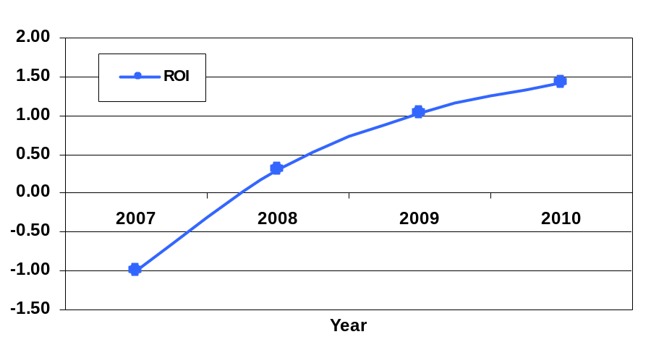

Conclusion and Recommendations
<< In general, it is best to organize these into (conclusion-recommendation) pairs, for example:
C1. Component 1 has by far the best performance, but runs only on Windows, failing the acceptable portability criterion. Component 2 is fully portable, and has acceptable performance.
R1. Use Component 2 for the oversize image viewer function.

C2. The DBMS assessment is still underway, and Component 2’s interoperability is still uncertain.
R2. Perform an interoperability assessment between Component 2 and the two DBMS finalists. >>

